Chapter No: 04 : System Design

4.1 Basic Modules:
Use Case Diagram:
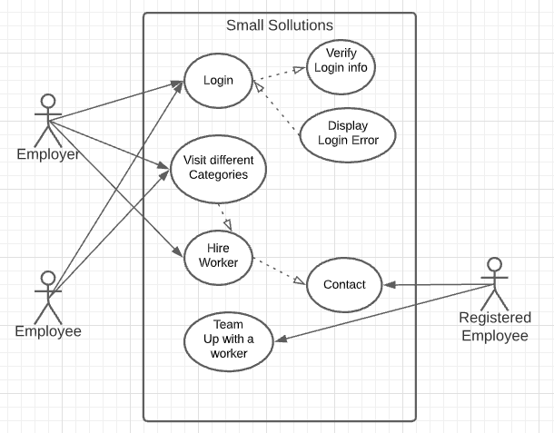

System flow diagram: 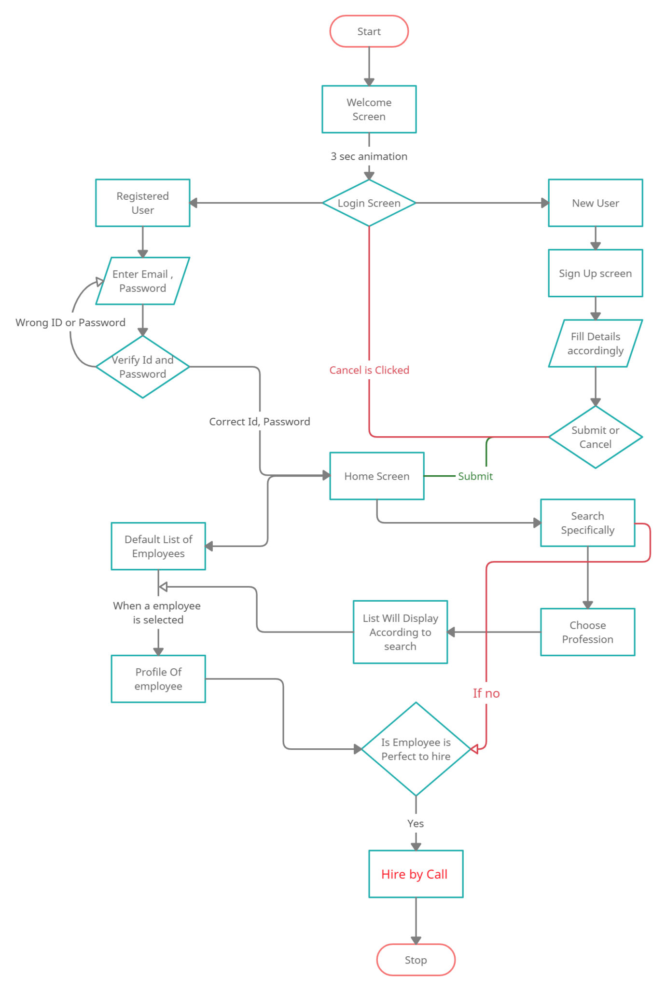
4.2 Data Design:
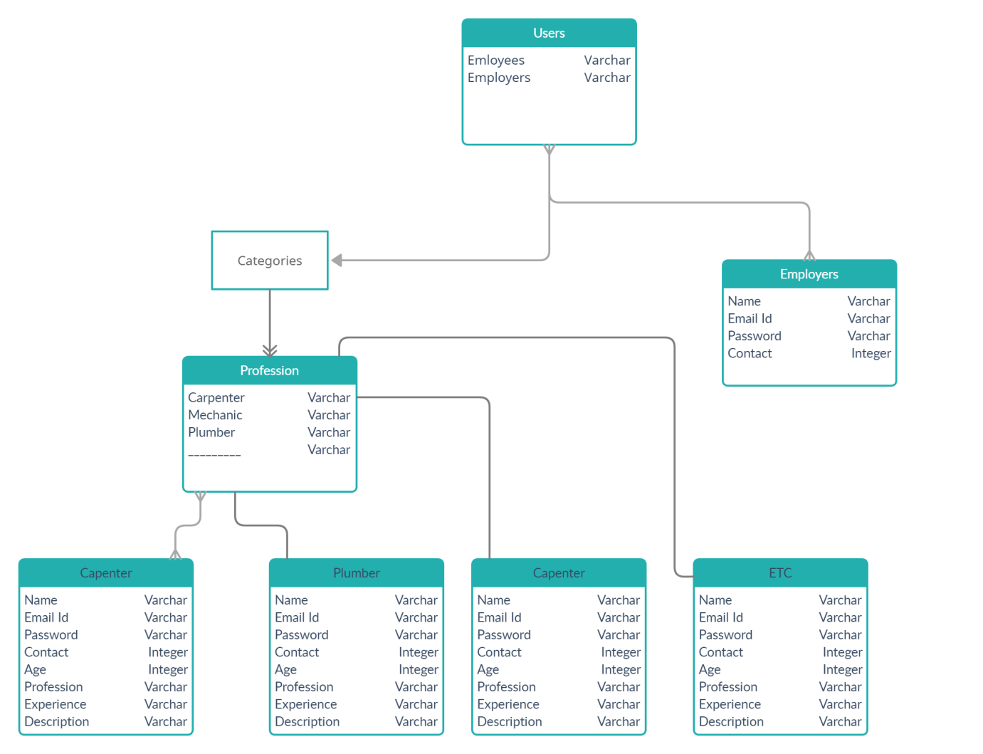

4.3 Procedural Design:
4.3.1 Logic Diagram:
Activity Diagram:
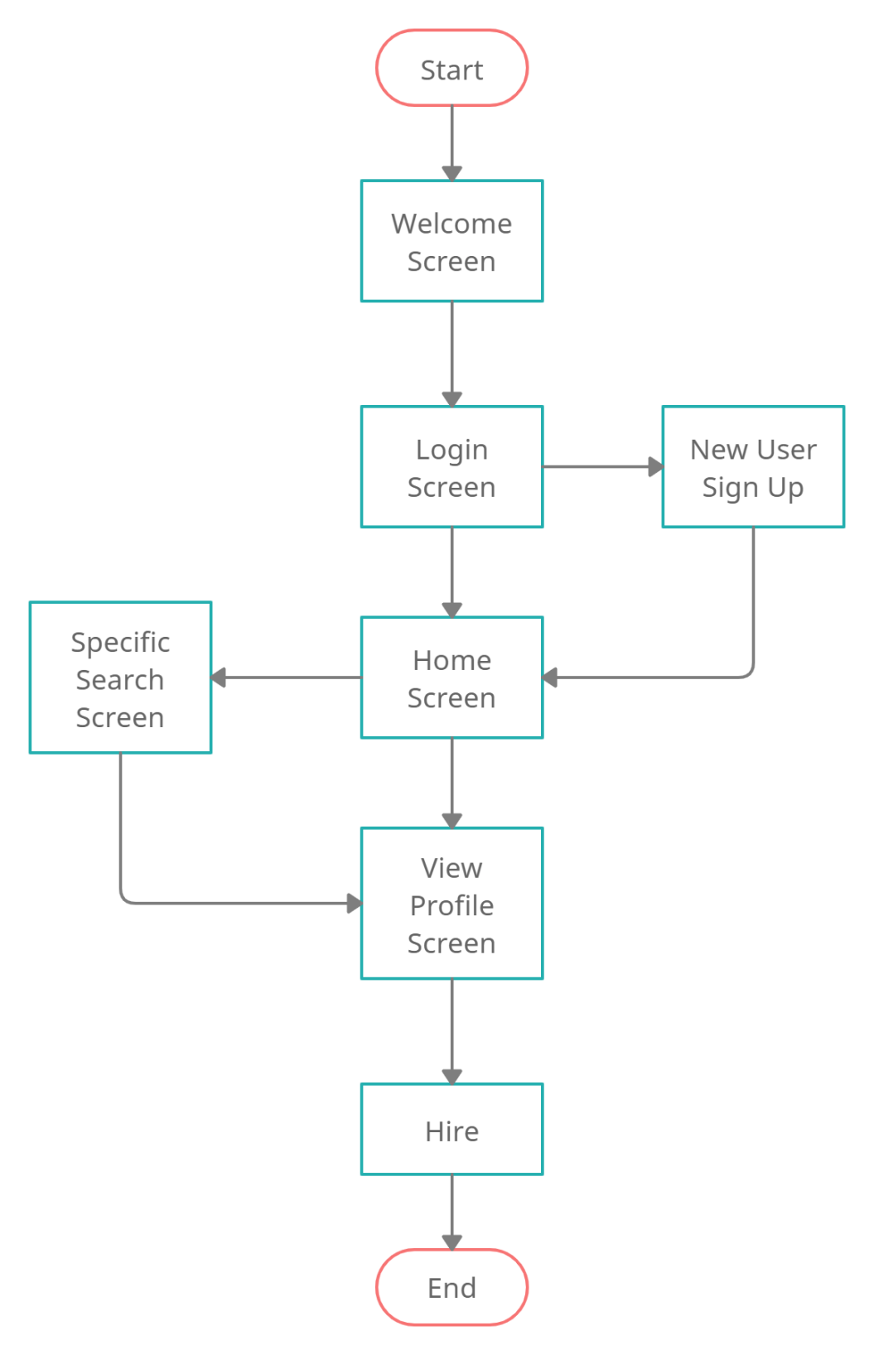

Sequence Diagram:
